Project 2 Read Me

Steven Anderson

READ ME

Animal Shelter Database

Steven Anderson

**About the Project**

This project, developed for Grazioso Salvare, is a database and controller that allows the user to track animals in shelters in the Austin, Texas area. It provides information like their name, their training status, their age, and their current adoption status. It uses a MongoDB database to store the information based of the datasheet. The project also includes a Python controller that works as a CRUD file for the MongoDB. The project when launched will display the logo of the company followed by a chart that shows all the animals in the database and allows for select choosing of animals. The animal chosen will then be displayed on the geo-chart below with their location based off lat and long. The chart also includes a filtering system that will filter the chart based of job type the dog can serve. Like water rescue or disaster rescue. Finally, there is a histogram located on the bottom left of the screen with zoom options that will allow a user to zoom in and see how many of a certain breed are in the database.

**Motivation**

The motivation of this project is the help the company Grazioso Salvare with an organized database that allows them to search the Austin, Texas area for dogs that can be trained for different emergency services. While also giving them a look at the total amount of animals in the greater Austin area. For the clients needs it is important that the charts show location of the selected animal and how many of those breeds of animal are in the area.

**Installation**

* Python 3.9.0 (download from [www.python.org](http://www.python.org))
  + Version of python used for the programming of the python database controller. An object oriented language that has built in data-structures that help with this project.
* PyMongo (download from pypi.org)
  + Driver library that contains the tools to make python work with MongoDB. It helps in the creation of the CRUD file used in this project.
* Jupyter Notebook (download from Juptyer.org)
  + An open-source online application for computing that helps with creation and modification of documents. In this project we take advantage of its testing capabilities using it to connect our .py file with a testing .ipynb file. This will also be used to launch the final screen showing the charts.
* MongoDB (download from [www.mongodb.com](http://www.mongodb.com))
  + A database program that uses NoSQL and JSON documents. It is compatible with many languages including C++, Python, and Python. It is also a schema-less database, this means it doesn’t need a blueprint to manage data. It is also a very flexible database compared to SQL databases. In our project we use MongoDB to create our database with our datasheet.

**Getting Started**

Starting the project will include first connecting the datasheet information for the sheltered animals to a MongoDB database. Using the command mongoimport in terminal you import the aac_shelter_outcomes.csv file. It is important to make sure you have your correct username and password along with the proper port and host. The db should be called AAC and the collection is called animals.

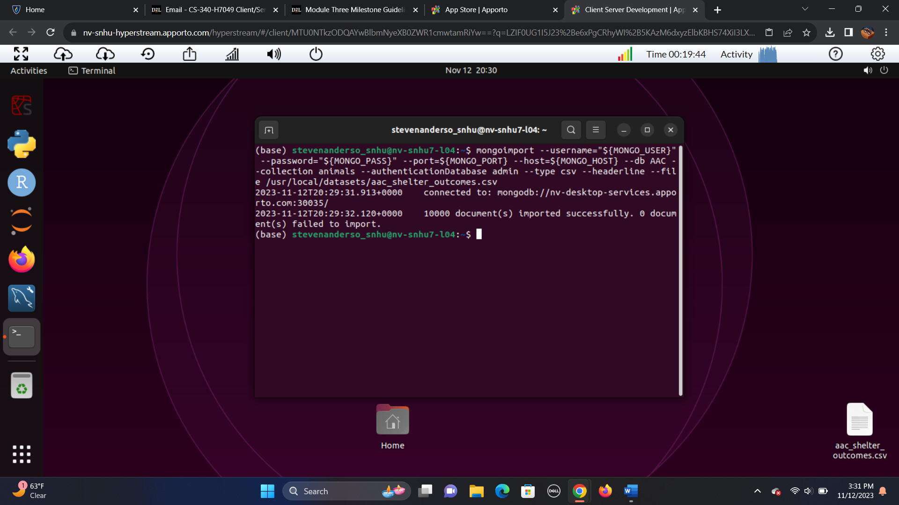

After importing the data into the database, a new user will need to be created to establish connection to the database for our later python controller. For this project the user is called “aacuser” and the password is “animal123”. When creating a user you use the command db.createUser(). Sending with this command the name, password and roles of the new user.

Next step is to make the controller. This controller will be coding in python and will be the CRUD and connection file. First step is to connect it to the MongoClient.

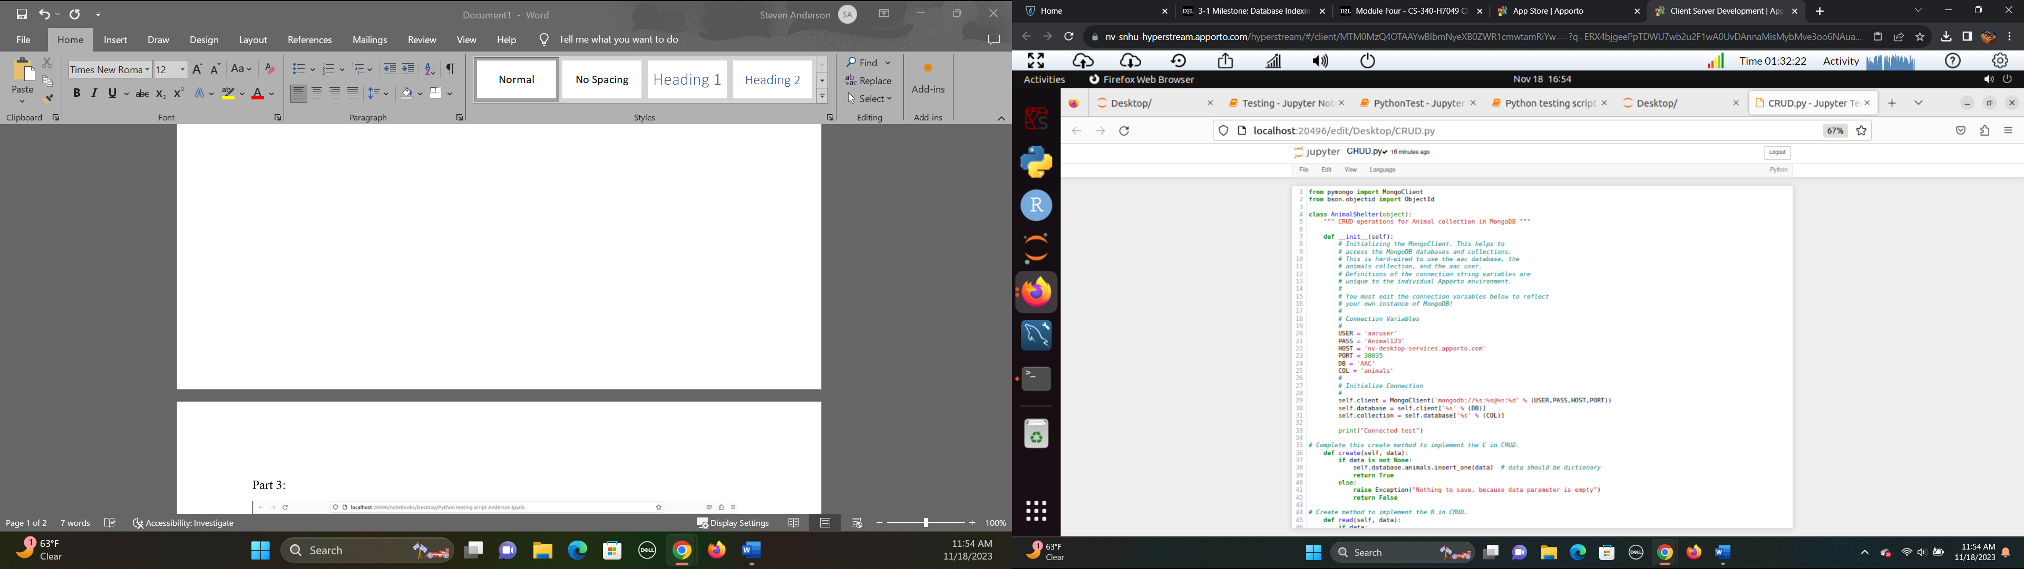

Next you have to initialize the MongoClient by connecting with the proper username and password along with the proper host and port.



The most important and used portion of the CRUD in this file is the R(read). This function is made by using a cursor that as long as the readData sent through read isn’t empty will read the data and print out the animals.

def read(self, readData):

cursor = []

if readData is not None:

cursor = self.database.animals.find(readData)

return cursor

#for animals in cursor:

#print(animals)

else:

raise Exception("Enter a criteria to search")

**Testing**

Testing the added chart features and logo involves running the (.ipynb) Jupyter Notebook file using the command app.run_server(mode='external', debug=True, port=30035). Where port is whatever port you are using.

Fist step in the testing is to ensure that the username and password get passed to the CRUD file for connection to the MongoDB database. This is done by importing the AnimalShelter database from the CRUD file. Then sending the username and password through the database so it can be assigned withing our Jupyter Notebook file.

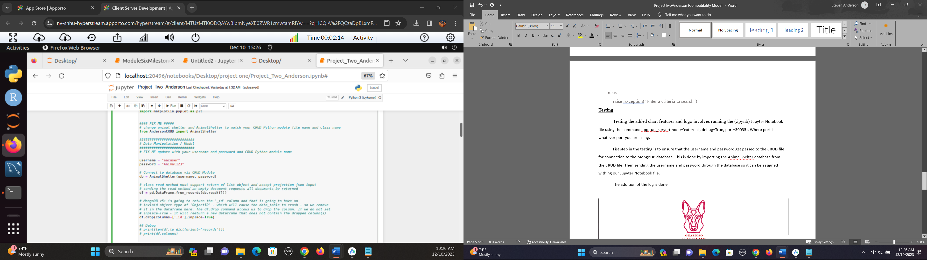

Once connection has been established, we have to include the Grazioso Salvare Logo onto the screen. This is accomplished by first importing the logo and assigning it within the file then encoding it so it can be formatted. Then in the layout design including a line that will load the image by decoding it within out html.Center line for the image.

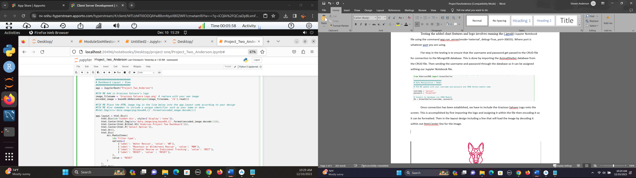

Then we have to establish our filters for the chart and how to display them. For this project a RadioItem was chosen which shows each option side by side with a circle to click for selection. This is then expanded upon when we move to update_dashboard which will update our dashboard chart with what filter(s) are selected. Filters are done by using panda DataFrame commands which list out each entry that fits the criteria stated. In this project one of the criteria was for water rescue dogs, it requested these dogs to be Intact Females between the week ages of 26 – 156 weeks of age. Further requesting the breeds be Labrador Retriever Mix, Chesapeake Bay Retriever or Newfoundland. ­

*(note that in this version of the project the filtering was not working properly)

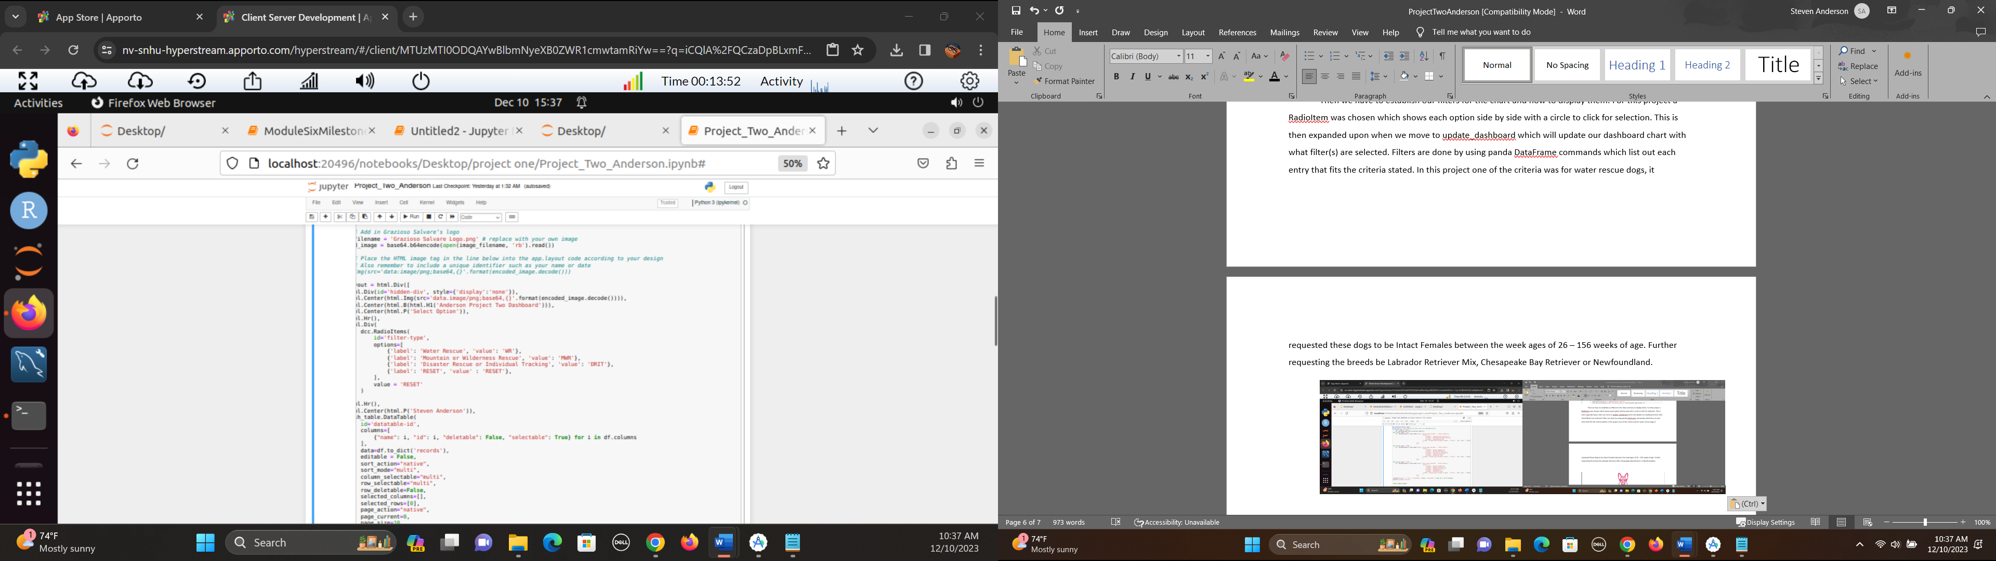

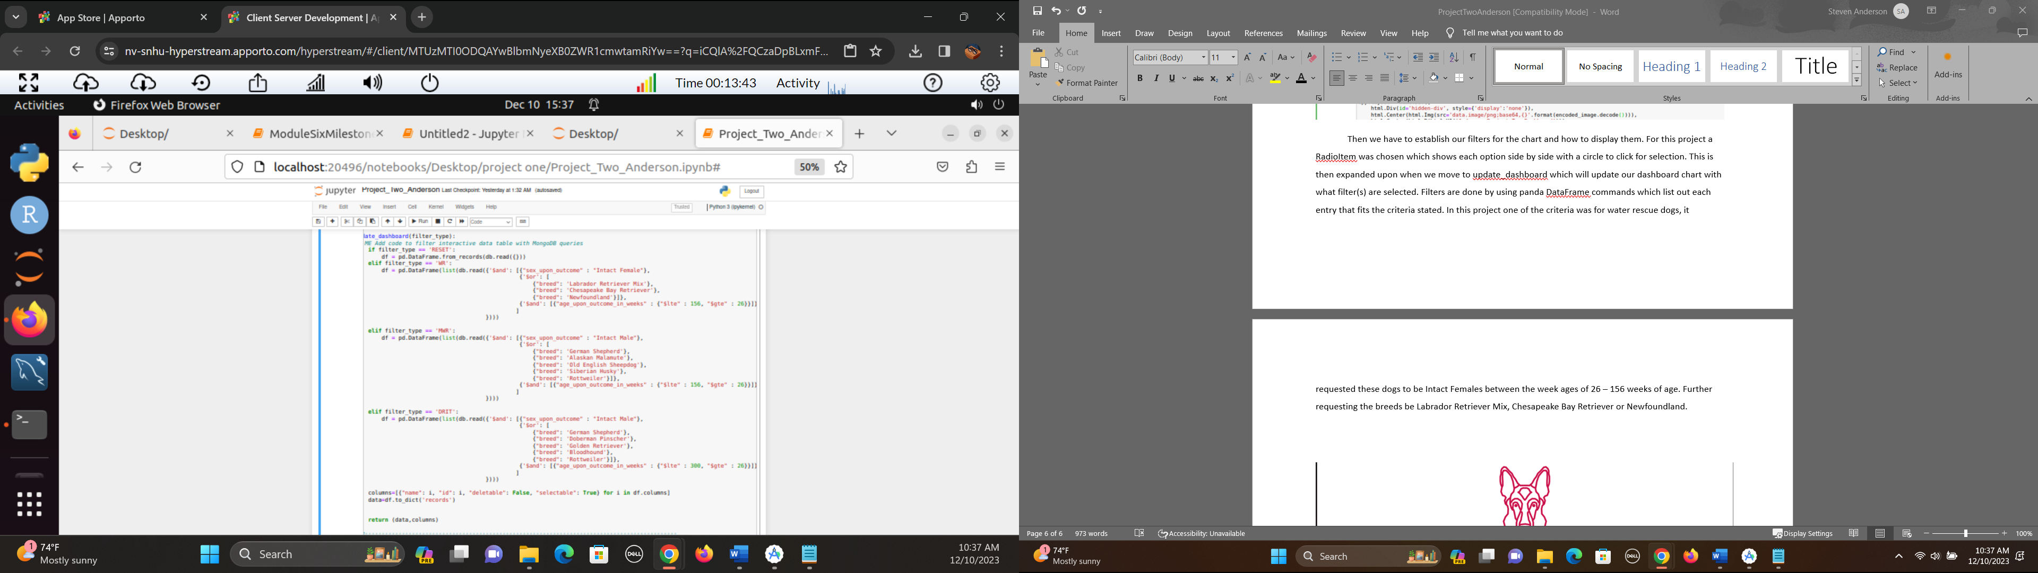

The next part of this testing came in forming out histogram chart that broke down the database by breed. This included using panda’s DataFrame and histogram function. When making the update_graphs function the return will be the histogram. With the two sent values into the histogram function being the database and the filter of breeds.

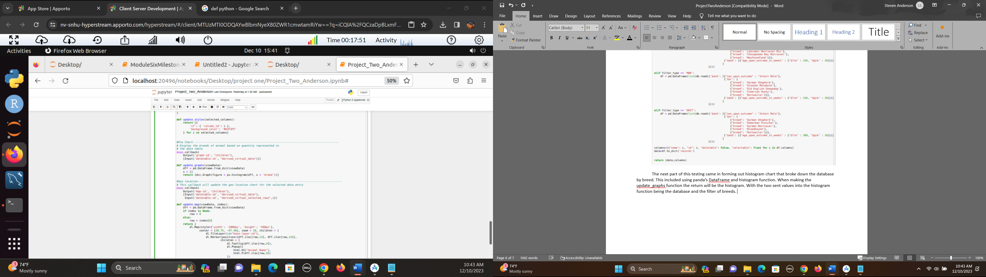

Finally we launch using the command app.run_server(mode='external', debug=True, port=30035). This will launch the dash app and give a link within Jupyter Notebook.

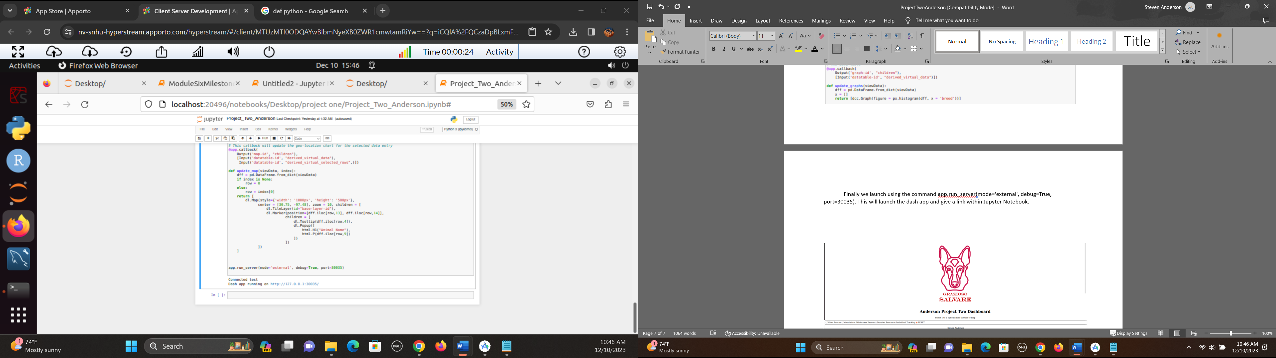

The link will open up the dash application for the project.

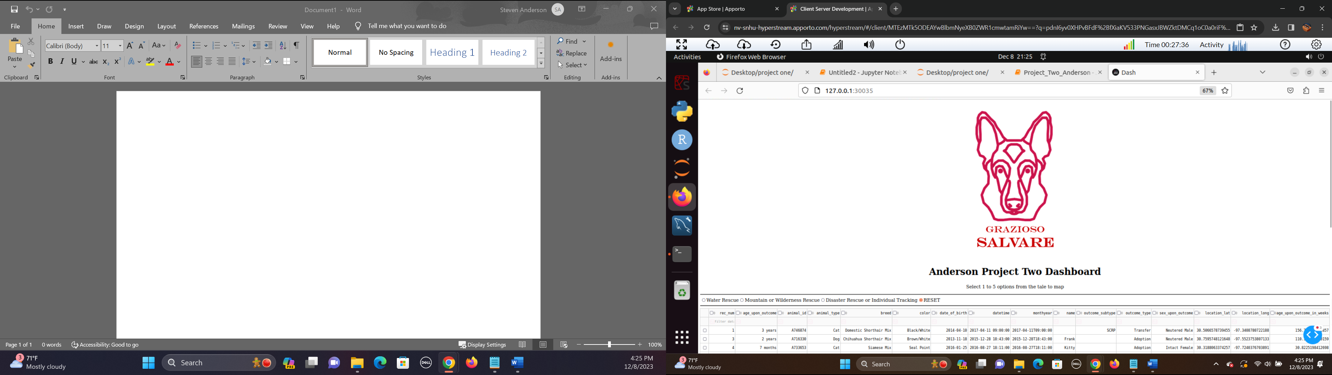

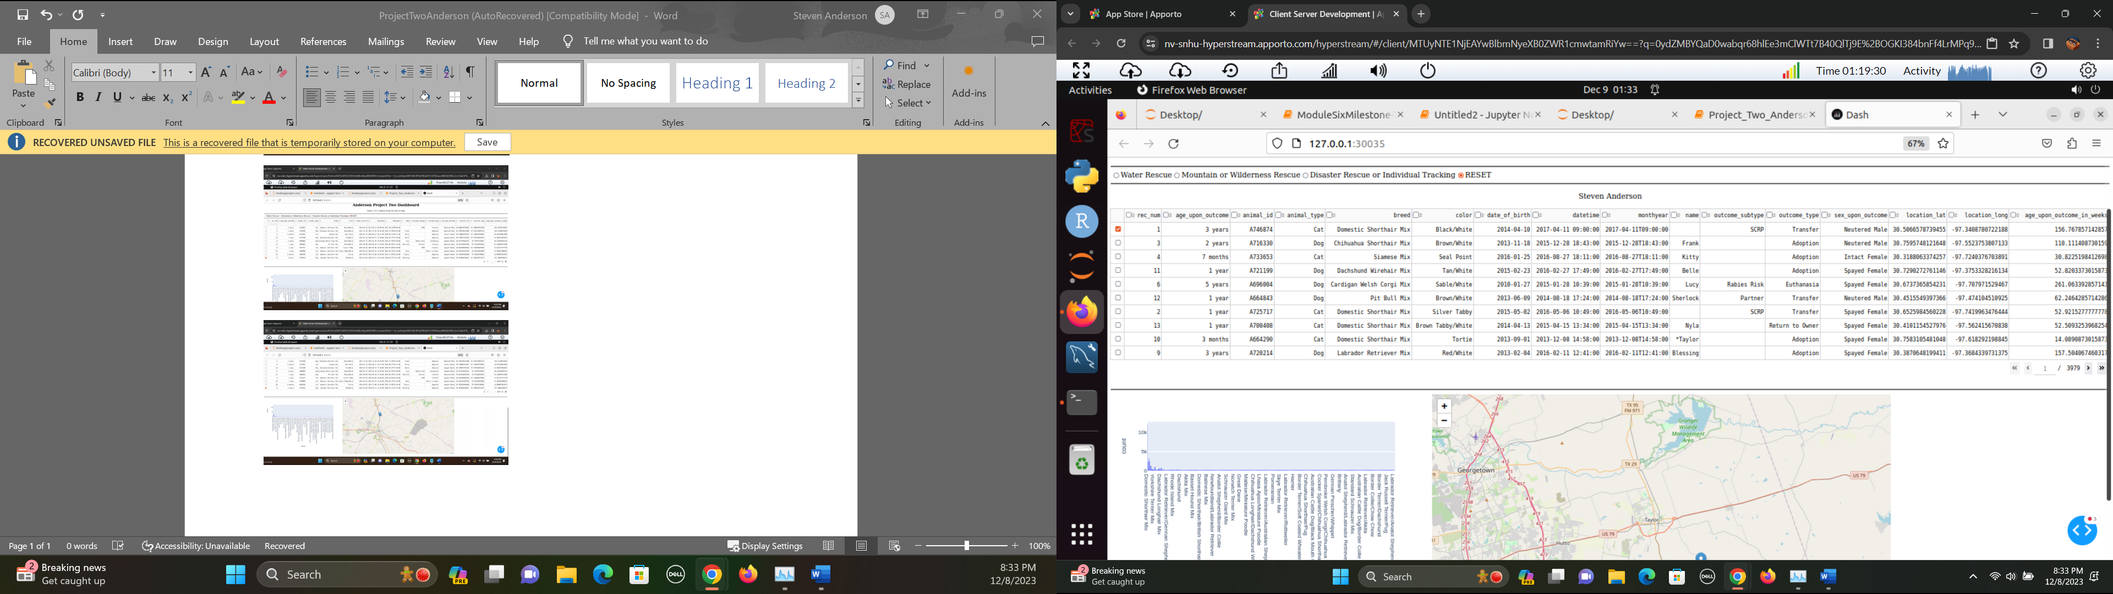

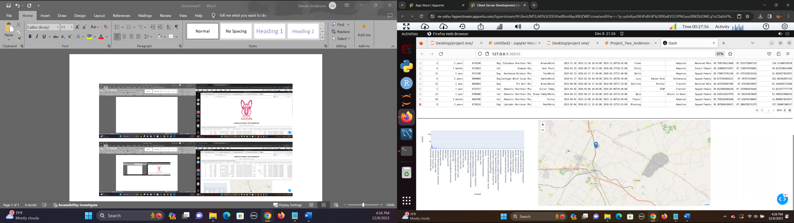

*(Second screenshot to show the histogram being zoomed in and the geo-chart being updated.)

